Gerbang Logika untuk RS FLIP FLOP (FF) dengan clock
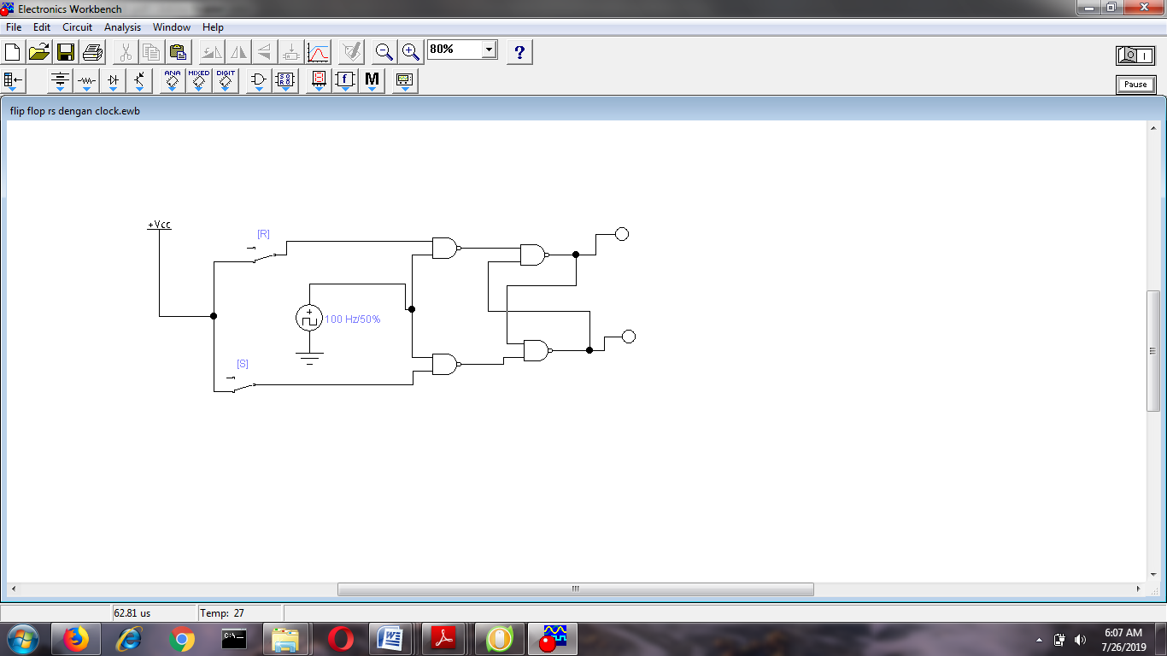

ANALISIS DATA
No | NAMA MAHASISWA | SIKLUS I | SIKLUS II | Absolute gain (d) | xd | x²d
1 | ABDILALUDDIN | 71 | 76 | 5 | -0.786 | 0.618 | 5.786
2 | BAIQ JIHAN SALMA R.H | 45 | 71 | 26 | 20.214 | 408.606 | 5.786
3 | BAIQ OKTAVIA ZAHRRANI | 66 | 69 | 3 | -2.786 | 7.762 | 5.786
4 | DEWI NURMILA SARI | 56 | 76 | 20 | 14.214 | 202.038 | 5.786
5 | FAIZAL | 74 | 71 | -3 | -8.786 | 77.194 | 5.786
6 | FEBRIAN PUTRA RUSMANA | 72 | 75 | 3 | -2.786 | 7.762 | 5.786
7 | GUSTI AYU DIAH ARI | 67 | 75 | 8 | 2.214 | 4.902 | 5.786
8 | IIN HARDIANTI IRAWAN | 63 | 68 | 5 | -0.786 | 0.618 | 5.786
9 | INDAH AYU JULIANI | 74 | 70 | -4 | -9.786 | 95.766 | 5.786
10 | IQBAL ANUGRAH CHATAB | 72 | 78 | 6 | 0.214 | 0.046 | 5.786
11 | ISNA NAILY | 73 | 70 | -3 | -8.786 | 77.194 | 5.786
12 | M. KHILAL MAULANA | 72 | 77 | 5 | -0.786 | 0.618 | 5.786
13 | MASRO HIKMAYANI | 76 | 72 | -4 | -9.786 | 95.766 | 5.786
14 | MAULANA ISTIGFAR. H | 58 | 72 | 14 | 8.214 | 67.470 | 5.786
 | Jumlah | 939 | 1020 | 81 | -0.004 | 1,046.357
 | Mean | 67.071 | 72.857 | 5.786
 | Md | 5.786
 |  | 1,046.357 |  |  |  | 5.749215077
 | N | 14
 |  |  |  |  |  | 2.397752088
 |  |  |  |  |  | 2.41297

