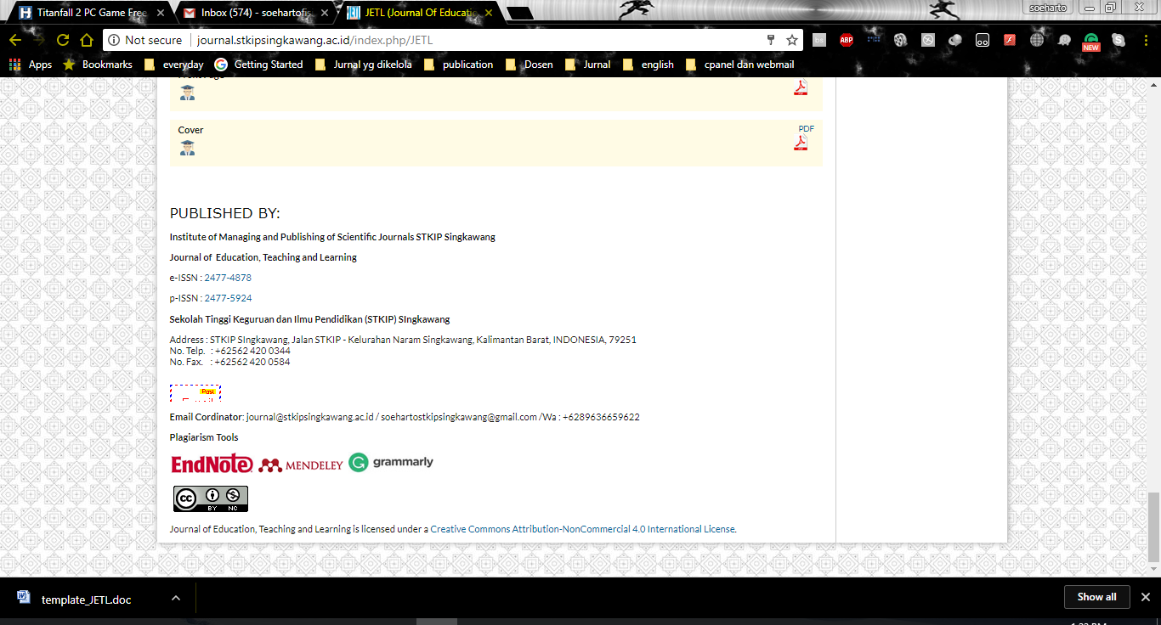
Journal of Education, Teaching, and Learning is licensed under
A Creative Commons Attribution-NonCommercial 4.0 International License.

Strategies Of Supporting Progressed Learners For Quality Teaching And Learning In Vhembe District, Limpopo, South Africa
F.T. Muedi¹, A.P. Kutame², T.Z. Ngidi³, & C. Uleanya^{4*}
^{1,2,3} University of Zululand, South Africa
and:
^{4*)}University of South Africa,, South Africa
E-mail: chinazamosese90@gmail.com

