
International Journal of Multi Discipline Science (IJ-MDS)

Vol. 2 No. 1 (2019)

e-ISSN: 2615-1707 . Pages: 1- 3

International Journal of Multi Discipline Science (IJ-MDS) is licensed under
a Creative Commons Attribution-NonCommercial 4.0 International License .

Implementation of Waitress Performance in Service at Feast Restaurant Sheraton Bandung Hotel And Towers

Seviani Hernanda
Program Studi D3 Perhotelan, Fakultas Ilmu Terapan, Universitas Telkom, Bandung
sevianihernanda292@gmail.com

Keywords :  Performances, Service, Waitress | ABSTRACT  This study discusses how to implement the performance of waiters in providing services at the Feast Restaurant Sheraton Bandung Hotel and Towers. The performance of the waiter itself is the key to the success of the service in the restaurant, because it is closely related to the quality of the service to be able to compete with other restaurants. In this case the duties and responsibilities of the waiter are needed so that they can be carried out properly. This strategy was created as a reference for dealing with the constraints that exist at the Feast Restaurant Sheraton Bandung Hotel and Towers. In this study the authors used qualitative methods with the type of data collection observation, interviews and literature. The results of this study are expected to contribute to the servers at the Feast Restaurant Sheraton Bandung Hotel and Towers in carrying out their operations.

INTRODUCTION

Hotel is one of the many accommodations used by a number of people in lodging services, food and beverage providers. Food and beverage service providers are part of the hotel industry. For now, it is very easy to obtain services that provide food and drinks, including hotels that have restaurants. The restaurant is a communal and professionally managed food and beverage provider used by the F&B Department, because a restaurant is a must-have facility for a hotel.
Addressed at Jl. Ir. H. Djuanda No. 390 Dago, Coblong District, Bandung City, West Java. The Sheraton Bandung Hotel and Towers is surrounded by green nuances with beautiful garden and mountain views, this hotel offers an unforgettable stay experience with comfort, the best service commitment, open space in all areas of the hotel as well as a strategic location in the premium area of Bandung city, near with tourism and business areas . Therefore Sheraton Bandung Hotel and Towers is able to compete in service with other 5 star hotels in Bandung.
Sheraton Bandung Hotel and Towers is one of the targets for foreign tourists and local tourists in providing accommodation for tourists who want to rest. One of the departments that fulfill basic human needs is the Food and Beverage Department . This department manages to meet the needs of guests by providing restaurant and waiter performance in their services. Guests who enjoy food and drinks certainly want to get good service from the waiter, especially the waiter must be able to understand what the guests need. The waiters at the Feast Restaurant Sheraton Bandung Hotel and Towers themselves serve their guests with predetermined SOP conditions. The waiters themselves provide the best service by knowing the preferences of the guests themselves, interacting when guests are in the restaurant, knowing the restaurant menu and recommending it to their guests, handling complaints, working with the team and attending development training every month.
With the good performance of waiters in restaurants to guests, it can provide added value to the hotel in good service. In this case the duties and responsibilities of the waiter are needed so that they can be carried out properly. The performance of the waitress itself is the key to the success of the service in the restaurant, because it is closely related to the quality of the service. To remain competitive with other restaurants, each restaurant must be able to improve the performance of their waiters/waitresses to be able to create customer satisfaction which can affect customer loyalty. (Yusup, 2023)
Service quality is the relationship between the quality of service that waiters provide and what consumers feel. Therefore we know how and when to do it, where and by whom to do it. Based on the results of direct observations made at the Feast Restaurant Sheraton Bandung Hotel and Towers, that the performance of waiters on smooth operations is still not what the company expects and needs to be improved to achieve good results again. Meanwhile, according to Ardjuno (2008) that the service quality of waiters must also use the highest standards in appearance at all times, presenting the ability to provide satisfaction to guests as the main goal, while continuing to learn new things to improve service quality.
Based on this opinion, it can be seen that service quality is providing service perfection to achieve customer desires or expectations. Service quality has a close relationship with customer satisfaction, with this encouragement service quality can provide a strong bond with the company. To find out the performance capabilities that a waiter provides, it is necessary to know the Standard Operating Procedures at the Sheraton Bandung Hotel and Towers Feast Restaurant.
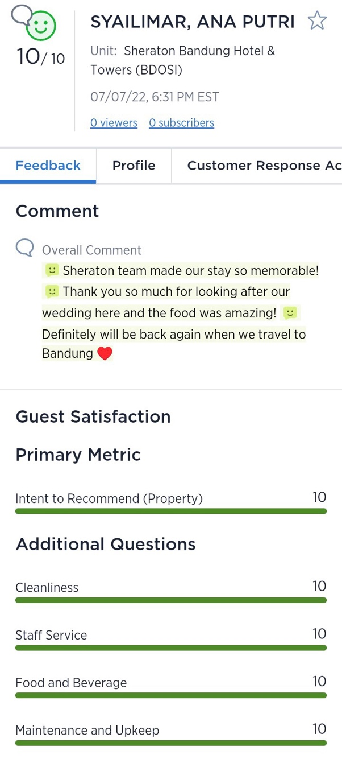
Figure 1 . Medalia Guest Voice Sheraton Bandung Hotel and Towers
A waiter is required to have good performance in providing service to restaurant guests, where it is this performance that makes guests come back. Based on the problems above, this study aims to analyze the Implementation of Waiters in Services at the Feast Restaurant Sheraton Bandung Hotel And Towers.
In order to overcome the problems that have been identified, a web-based application has been developed that aims to manage sales and payroll. This application is specifically designed to monitor the performance and quality of servers at Feast Restaurants, Sheraton Bandung Hotels and Towers. This application will also ensure that the services provided by the waiter are in accordance with the standard operating procedures of the restaurant. This study has limitations that focus on the performance of waiters in service at the restaurant, with an emphasis on the relevant departments. The purpose of this research has practical and theoretical benefits. Practically, the results of this study can be used as a reference and innovation in improving the implementation of waiter performance in service. Theoretically, this research will contribute to the D3 Hospitality study program at Telkom University as a source of new insights. In addition, this research will broaden the author's insights about the management and quality of being a good waiter and provide guidance for further researchers who are interested in the same topic.

METHOD

The location of this research is located at the Sheraton Bandung Hotel And Towers which is a hotel with the largest brand of the Marriot International hotel chain. Sheraton Bandung Hotel And Towers is located on Jl. Ir. H. Juanda No.390, Dago, Coblong District, Bandung City, West Java 40135 ( 022 ) 2550303.
Qualitative research method used in this final project. This method does not rely on mathematical logic, numerical principles, or statistical methods, but rather focuses on understanding and analyzing the quality of human behavior. Qualitative research aims to retain the form and content of human behavior and analyze its qualities, rather than converting them into quantitative entities. This qualitative research involves design steps, including determining the research title, formulating the problem, and selecting data collection techniques. The research location was at the Sheraton Bandung Hotel And Towers, with data obtained from primary sources (interviews and direct observation with hotel employees) and secondary sources (internal and external hotel documentation and previous research). Research instruments include key information about employee positions and focus questions related to service quality.
Data collection methods and techniques include literature review, literature review, and online data searches to obtain relevant information. The field study involved interview techniques, observation, and documentation regarding the activities of the Drum United Bandung community. The process of data analysis includes data reduction, data presentation, and drawing conclusions, which are directed at understanding the implementation of the waiter's performance in service at the restaurant.

RESULTS AND DISCUSSION

Waitress Performance in Maintaining Service Quality at Feast Restaurant Sheraton Bandung Hotel and Towers
Based on the results of interviews with informants as Restaurant Managers . Maintaining the quality of service at the Feast Restaurant Sheraton Bandung Hotel and Towers is very important to ensure that the service provided to guests meets the expectations of the guests themselves. Based on the formulation of the problem raised, maintaining the quality of service at the Feast Restaurant Sheraton Bandung Hotel and Towers, the waiters do not forget to implement 5 service dimensions which consist of:
- Tangibles ( Real Evidence)
The results of the researcher's interview with the informant as the Restaurant Manager of the Feast Restaurant Sheraton Bandung Hotel and Towers, the benchmark for guest satisfaction at the Feast restaurant Sheraton Bandung Hotel and Towers refers to Medalia or what is called Guest Voice.
” Even though this hotel has been operating for 32 years, guests acknowledge that the quality of service provided has been maintained since the past. That is the reason why guests return to Feast Restaurant Sheraton Bandung Hotel and Towers.”
In maintaining guest satisfaction, apart from the waiter service aspect, Feast Restaurant Sheraton Bandung Hotel and Towers always innovates in holding special events, promotions, special signature menus, and Special Occasions.
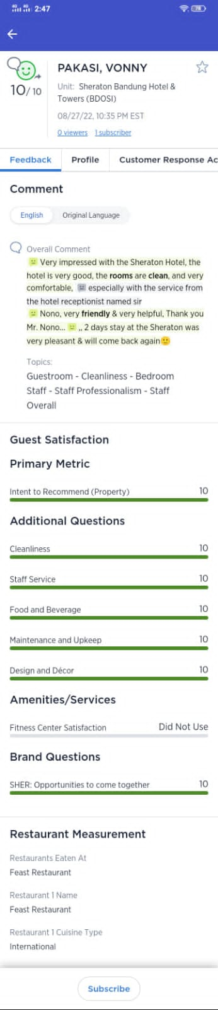
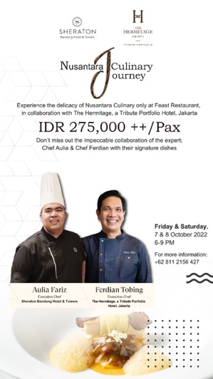
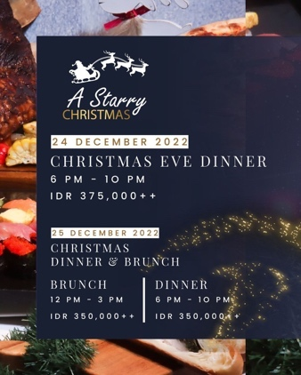

- Empathy (Empathy)
A waiter must have empathy in giving special individual attention to guests, such as when handling complaints. Feast Restaurant Sheraton itself has procedures for responding to handling complaints from guests. The LEARN Model is a method used by Sheraton Bandung Hotel & Towers in accordance with the value given by Marriott International when finding problems raised by guests who use or consume goods or services at Marriott properties . The LEARN method in question is,
- L, Listen , listen. Listen carefully to the issue, both content and emotion, don't interrupt, keep listening carefully and if needed, ask questions to clarify.
- E, Empathize , empathize. Feel what the guest/customer feels and provide a solution.
- A, Apology , apologize. Make apologies, body language and intonation, and professional apologies.
- R, Respond , provides a response. The response or action taken is to provide a solution. Adjust to the reaction given by the guest when submitting a problem.
- N, Notify , does notifications. After giving an appropriate response, a notification is made to the guest concerned and the team, so that this can be a lesson to become a better team in facing the same situation.
- Reliability _
With the ability of waiters to provide services according to guest expectations, Feast Restaurant Sheraton Bandung Hotel and Towers conducts DSU ( Daily Stand Up ) at every briefing. This DSU is useful for knowing and ascertaining what events the guests experienced during their stay at the hotel, history of food allergies, and guest preferences . So that when operations are running at the Feast Restaurant Sheraton Hotel and Towers, the waiters already have the basics and know the guest database from the DSU, and reduce operational errors in maintaining service quality.

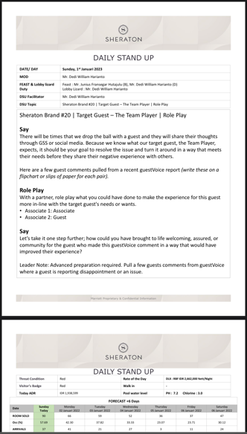

- Responsiveness _
By keeping in mind what guests need, the Sheraton Bandung Hotel and Towers Feast Restaurant has VIP Guest list data that makes it easy for the waiter to find out the guest's preference .
"So when guests come to the restaurant we can do personal touch directly to these guests, such as greeting by name , offering favorite food and drinks, escorted the sitting is in the smoking area or non smoking area .”
The needs of the guests while they are at the Feast Restaurant Sheraton Bandung Hotel and Towers are met so as to support the quality of service in it.
- Assurance _
Knowledge and courtesy, as well as the confidence of the waiters, are no less important during operations. That's where the waiters are given training every month.

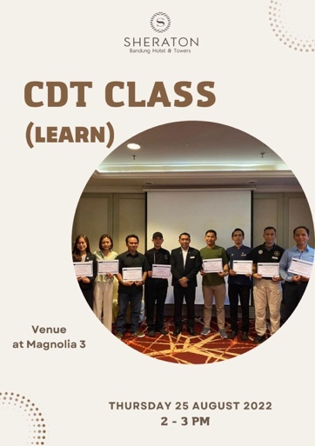

Implementation of SOP at Feast Restaurant Sheraton Bandung Hotel and Towers
SOP ( standard operational procedure ) is a guide used to ensure operational activities in restaurants so that they can ensure effective and efficient service to customers or guests in restaurants. Of course, the restaurants in the hotel have different SOPs ( standard operating procedures ), all of which are determined by the types of restaurants and the food served by the restaurant. Having an SOP ( standard operating procedure ) in a restaurant can certainly help waiters provide good service. The results of interviews with informants as Food and Beverage Service Agents show several SOPs ( standard operating procedures ) that are used at the Feast Restaurant Sheraton Bandung Hotel and Towers. 15/5 Rules , 15/5 Rules is one of the service standards that must be applied while carrying out tasks, the rules in question are:
- At a distance of 15 feet (approximately 4.6 meters), make eye contact and smile genuinely.
- At a distance of 5 feet (approximately 1.5 meters), make good eye contact and be polite.
- Give guests a warm and friendly welcome.

  - Work schedule
Feast Restaurant Sheraton Bandung Hotel and Towers has several work schedules for all of its employees. The following is the distribution of types of work schedules at Padma Hotel Bandung in accordance with Standard Operating Procedures (SOP ):

Table 6 Work Schedule
Schedule Code | Schedule Name | Working hours
M05 | MorningShift | 05.00 – 14.00
M06 | MorningShift | 06.00 – 15.00
M08 | MorningShift | 08.00 – 17.00
A12 | Middle Shift | 12.00 – 21.00
A14 | Afternoon Shift | 14.00 – 23.00
N08 | Night Shift | 20.00 – 05.00

Implementation of Standard Operating Procedures at the Feast Restaurant Sheraton Bandung Hotel and Towers has a different path for each of their respective roles. This work flow is seen from each work schedule and the implementation role. The following is the implementation of the standard operating procedures for the work flow section at Feast Restaurant Sheraton Bandung Hotel and Towers:

  - MorningShift
Description
Doing preparation before operating the restaurant for breakfast begins. The preparation was carried out by dusting tables and buffets , re-checking the table setup again , re-completing the requirements for the waiter/ss section table.
Offering coffee or tea to guests who have just come to the restaurant.
Acting as a waitress in charge of serving the needs and desires of guests during breakfast .
Perform closings operational when breakfast hours have ended.
Doing lunch buffet preparation. ( if any)
Taking orders for guests who come to the restaurant to eat a la carte . This is done until the final stage, namely billing.
Check parstock for restaurant operational needs, and pick it up at store purchasing every Monday-Friday.
Doing preparation for breakfast the next day by polishing glassware, chinaware, silverware.
  - Afternoon Shift
Description
Taking orders for arriving guests to a restaurant to eat ala carte. This is done until the final stage, namely billing.
Helping to prepare for breakfast the next day by polishing glass ware, chinaware, silverware.
Handling over with the morning shift if work time is over.
Doing dinner buffet preparations (if any)
Acting as a waitress in charge of serving the needs and desires of guests during dinner.
Perform closings operational when dinner hours have ended.
Back to back to setup breakfast needs the next day.

  - Code of Conduct
- All employees must arrive on time according to a predetermined work schedule by checking attendance using a finger print.
- All employees work according to the number of working hours, namely 9 hours/day.
- All employees must look neat, clean and smell good using uniforms according to Feast Restaurant Sheraton Bandung Hotel and Towers standards.
- All employees get 1 hour break.
- Each employee must make a handling offer to the employee who will be incharged afterwards.
- All employees are required to attend the briefing.
- All employees are prohibited from eating and drinking during working hours.
- If absent due to sick leave, each employee must attach a sick note on that day or no later than one day after.
- All employees must report to the FB Manager, Restaurant Manager, Asst. Restaurant Manager, or Restaurant Supervisor if there are problems and complaints from guests, especially at the restaurant.

CONCLUSION

Based on the description of the data that has been presented above, it can be seen that apart from the role of the waiter in a restaurant, guest comments can also affect the service provided by the waiter. From the results of the analysis the authors get various conclusions as follows:
- Based on the results of observational research and interviews that the authors conducted, the waiters at the Feast Restaurant Sheraton Bandung Hotel and Towers must be polite waiters who provide friendly service to their guests. Especially sensitive to the guest area, so that if guests need a waiter, they will respond quickly without the need to make guests wait long.
- Based on the results of observational research and interviews that the author conducted, the waiters at the Feast Restaurant Sheraton Bandung Hotel and Towers, that the way waiters serve guests is in accordance with the applicable SOP by having to adhere to the responsibilities that have been given and do their work based on the job desk in accordance with which has been set. So that the service to guests is carried out optimally.

Suggestion
After seeing and explaining the problems that occur, the author's suggestions for implementing waiter performance in maintaining service quality can be applied as follows:
  - Maintaining the quality of the Standard Operating Procedures owned by Feast Restaurant Sheraton Bandung Hotel and Towers in order to have excellent service quality for all guests.
  - Providing regular training so that they are more aware of their respective duties and responsibilities, as well as making it easier to carry out operations at the Feast Restaurant Sheraton Hotel and Towers.
  - Communication between sections in the Feast Restaurant Sheraton Bandung Hotel and Towers in order to unite understanding and media for channeling information to improve coordination in working together.
  - Evaluation to understand and fix existing problems in order to create a supportive work environment.

REFERENCES

Ardjuno, W. (2008). Culinary Knowledge. Jakarta: Erlangga.
Agusanwar, AP (2000). Tata Graha Hotel Operations. Jakarta: PT. Main Library Gramedia.
Bagyono, S. (2012). Tourism & Hospitality. Bandung: ALPHABETA, cv.
Marsum, A. (2005). Restaurants and All Their Problems. Yogyakarta: Andi.
Indonesia, KP (1987). MINISTER OF TOURISM, POST AND TELECOMMUNICATION DECREE NUMBER: KM. 94/HK.103/MPPT - 87 . Retrieved from https://jdih.kemenparekraf.go.id/asset/data_puu/regulation_subject_1567753049_km94hk103mppt_87.pdf
Tarmoezi. (2000). http://jurnal-sdm.blogspot.com/2009/07/pengantar-perhotelan-defined-hotel.html?m=1. Introduction to Hospitality .
Bagyono. (2012). Tourism and Hospitality. Bandung: Alphabet.
Soekarno, P. (1998). Food & Beverage Service Waitress. Jakarta: PT. Scholastic Library.
Sulastiyono, A. (2011). Management of Hotel Operations. Bandung: Alphabet.
Furchan, A. (2004). Introduction to Research in Education. Yogyakarta: Student Libraries.
Sugiyono. (2005). Introduction to Qualitative Research. Bandung: Alphabet.
Riyadi, H. (2015). Food and Beverage Service Knowledge. Bandung: Alphabet.
Murdjianto. (2001). Human Resource Management. Bandung: Bina Atmaja.
Sutrisno. (2009). Human Resource Management. Jakarta: Kencana.
Moenir. (2010). Public Service Management in Indonesia. Jakarta: Earth Script.
Yusup, I. (2023). The Effect of Standard Operating Procedures on Waitress Performance at Puri Santrian Resort and Spa. Denpasar.

